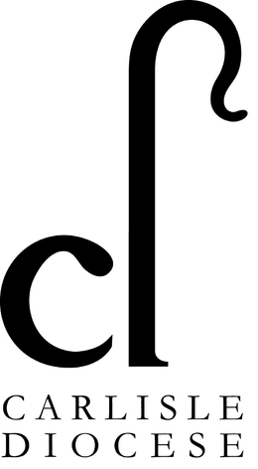
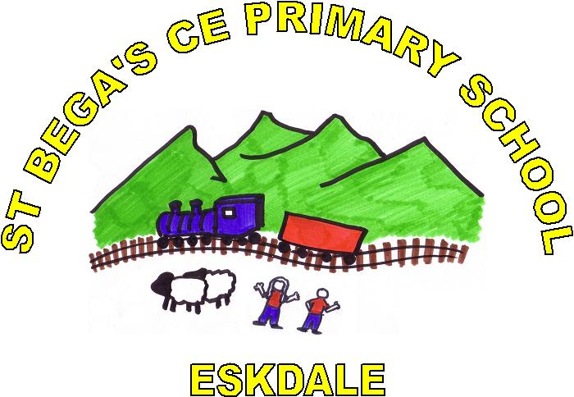

School Admissions Policy St Bega’s C of E Primary School
The Governors of St Bega’s Church of England Primary School are the Admissions Authority for the school. Following consultation with the Diocesan Board of Education and the Local Authority, the Governors have set the published admission number for access to the reception class as 12.
The parental pack contains information and an application form for admission to our school. It is also possible for an application to be made online on the Local Authority’s website.
An application for entry in September 2021 must be made subject to the LA closing date of 15th January 2021.
Parents are encouraged to name three schools in order of preference on the application form. The Governors operate a system whereby they consider all preferences equally. So the order of your preferences will not be used in considering your application. (It will only be used if a place is available for your child at more than one school.) Places at this school will be allocated according to this Admissions Policy and the Local Authority’s Coordinated Admissions Scheme. A letter / email informing parents of the success or otherwise of their application will be sent out by the Local Authority in April. Parents of those children not offered a place will be informed of the reason and offered an alternative school by the Local Authority. They will be informed of their right of appeal.
All children will be admitted unless there are more applicants than places in which case the Governors will make allocations using the following criteria. These are listed in order of priority.
1. Children who are in Public Care or who have been adopted (or became subject to a child arrangements order or special guardianship order) but were formerly in Public Care. This also includes children who were previously in Public Care outside of England. A child in public care is defined as a child who is looked after by the Local Authority within the meaning of section 22 of the Children’s Act 1989.
2. Children who have physical and/or medical needs who would be disadvantaged by travelling to another school. Written evidence from an appropriate professional would be required for the Governors to consider admission in this category.
3. Children living within the catchment area having a brother or sister attending our school at the time of their admission giving priority, if necessary, to those children with the youngest siblings. Brothers and sisters are those living at the same address including step, adopted and foster children.
4. Children living in the catchment area
5. Children who have attended St Bega’s Nursery on our site.
6. Children living outside the catchment area who, at the time of their admission, have brothers or sisters in the school. Brothers and sisters are those living at the same address including step, adopted and foster children.

7. Children living outside the catchment area. A map of the catchment area is available from school.
The criteria outlined above will be strictly followed there being one exception. If a child has an Education Health Care plan naming St Bega’s Church of England Primary School then irrespective of the criteria the child will be admitted as in these circumstances the Governors have a statutory duty to admit the child concerned.
Tie Break:
In some categories, where there are more applicants than places available, age will act as a determining factor but unless specified it will be distance. The distance is measured from the centre of the child’s address to a common point on the school site. The measurements will be by the shortest walking route by road. The Governors will use the Local Authority’s computerised Geographical Information System (GIS) to ensure consistency of measurement. The closest addresses will have priority.
Address of Pupil:
The address on the application form must be the current one at the time of application. Where a child can live at more than one address the home address is to be the one where the child sleeps and thus wakes up for all or the majority of the school week. Where there is any doubt the governors reserve the right to verify the information provided by the parent(s), for example, through the GP or the child benefit address.
In Year Admissions.
In year admissions are those which occur outside the “normal” admission time. If you wish your child to attend St Bega’s Church of England Primary School you should visit our school and admission details will be provided. If your child is refused a place you will be informed of your right to appeal.
Fraudulent applications:
If the Governors of St Bega’s Church of England Primary School discover that a child has been awarded a place as a result of an intentionally misleading application from a parent, for example, an incorrect address and as a result it effectively denies a place to a child with a stronger claim then the Governors will withdraw the offer of a place. The Governors will reconsider the application and the right of appeal offered if a place is refused.
Deferred Admission:
For children beginning School following their fourth birthday admission is normally in September. However, if you wish entry can be deferred until later in the year or until the term in which your child reaches compulsory school age. For example if your child’s fifth birthday is between September and December then, if you wish, admission may be deferred until the beginning of the Spring Term. If it is between January and April admission may be deferred until the beginning of the Summer Term. You can also request part time education until the term in which your child reaches compulsory school age. The Governors recommend that in your child’s interests full time education is deferred no later than the start of the Spring Term.
Appeals Procedure:
If the Governors are unable to offer your child a place because of over subscription you as a parent have a right of appeal under the School Standards and Framework Act 1998 as amended by the Education Act 2002 and subsequent legislation. You should notify the Clerk to the Governors of St Bega’s Church of England Primary School within 20 school days of receiving the letter which will give the grounds for refusing a place. As a parent you will have an opportunity to submit your case to an independent (of the Governors) appeals panel. You must set out your grounds for the appeal in writing. You will normally receive at least 10 school days notice of the time and venue for the appeal hearing where you will be able to present your case in person. This right of appeal does not prevent you from making an appeal in respect of any other school. The Independent Appeal will be organised on behalf of the Governors by the Local Authority Legal and Democratic Services Unit at Carlisle.
Waiting List:
Those children who are not offered a place may, if the parents so wish, be placed on a waiting list. The names will be placed on the list in the order of the admissions criteria. Late applicants will be slotted into the list according to the admissions criteria. It is thus possible for a child recently arrived in the area to have a higher priority than a child who has been on the waiting list for some time. Irrespective of whether an appeal has been submitted, if a place becomes available it will be offered to the child at the top of the list. The waiting list will remain open for the whole of the first term in the year to which it relates.
Infant Class Size:
If your child was refused a place in a reception or key stage one class because of Government limits on infant class size, the grounds on which your appeal could be successful are limited. You would have to show that the decision was one which no reasonable governing body would have made or that your child would have been offered a place if the governors’ admissions policy had been properly implemented.
Multiple births:
The Governors of St Bega’s Church of England Primary School will ensure as far as possible that twins, triplets or those children born in the same year are not separated. Such children will be given priority in any particular category.
Excepted pupils:
While no infant class is to contain more than 30 pupils there can be very limited exceptional circumstances. The admittance of such a child(ren) will be known as an “excepted pupil” for the time they are in an infant class or until the numbers fall back to the size limit. An excepted child would be one whose twin or sibling from a multiple birth is admitted otherwise than as an excepted pupil. It might also include a child born in the same school year, a child with an education health care plan or looked after child or a child of a UK Serviceman to be admitted outside the normal admission period.
Nursery:
If you have a child in our Nursery School/Class then you must make a separate application for the Reception Class. A place in our Nursery School/Class does not guarantee a place in our Reception Class.

Signed E Stellmacher
Headteacher
Signed Madonna Adams
Chair of Governors
Date October 2019
This policy will be reviewed
Date October 2020

