Eden in Eskdale
Fundraising Target = £30k
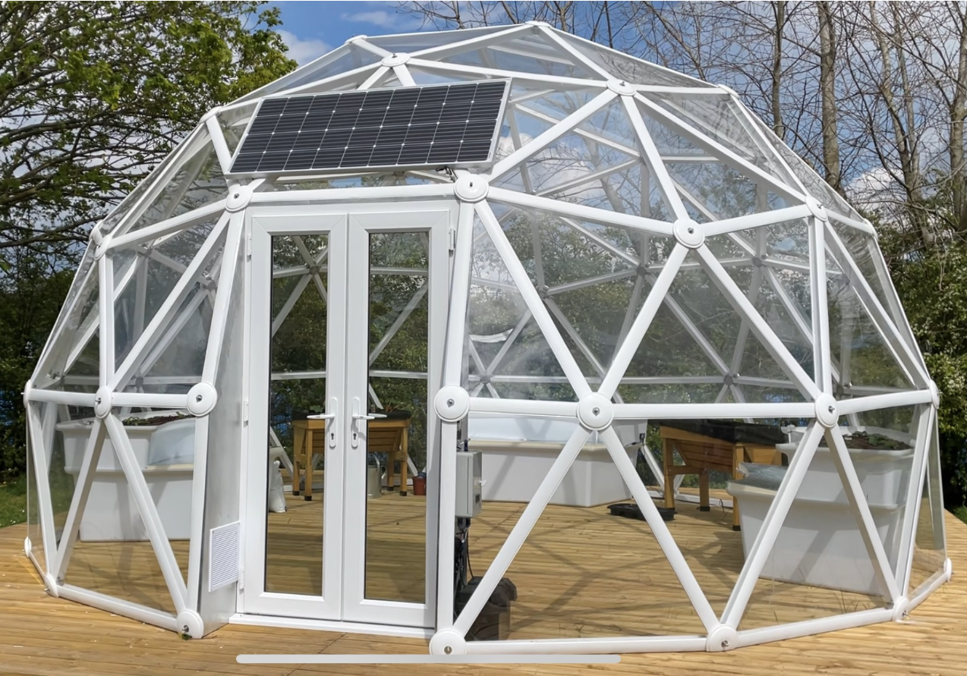
We want to install a BioDome system at school to teach children food/plant growing skills to enable them to contribute to a more sustainable local community, whilst supporting their mental wellbeing.
We will use the funds raised to purchase a fully installed 20ft biodome system, which includes the biodome, wooden or concrete base and aquaponics system for growing plants in a closed ecosystem. We will also buy equipment (e.g. seeds, compost, planters and tools) for more traditional growing methods. We will always choose the best value option.
The project will help the local children to develop a wide range of skills including:
- Knowledge about plants and what they need to grow and the different methods of growing.
- Commercial and entrepreneurial skills – the children have a plant stall at the large community events in Eskdale and this requires them to develop skills such as planning, pricing, selling, giving the correct change, donating the funds raised to FOES. The running of the plant stall gives the children a strong sense of pride that they have contributed to the school.
- Social skills that will develop through the running of the plant stalls and selling to their customers.
These skills give the children the capability to support a sustainable future for our community.
We hope to achieve a fundraising target late 2022 to enable us to install the BioDome system as soon as possible after that

