St Bega’s C of E Primary School Progression Framework for a worldviews approach
(from the Draft Handbook for Religion and Worldviews in the Classroom by the RE Council 2022)
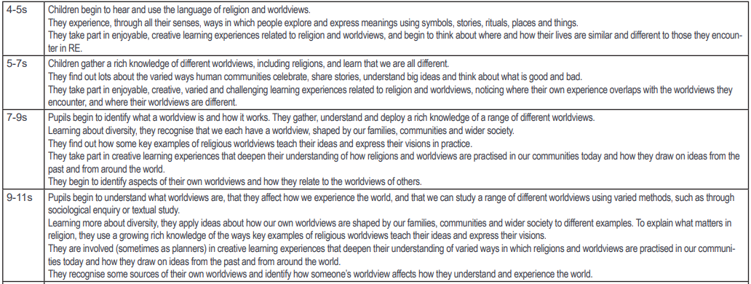

St Bega’s End of Key Stage Expectations
(from Cumbria SACRE 2023)
