St Bega’s C of E Primary School

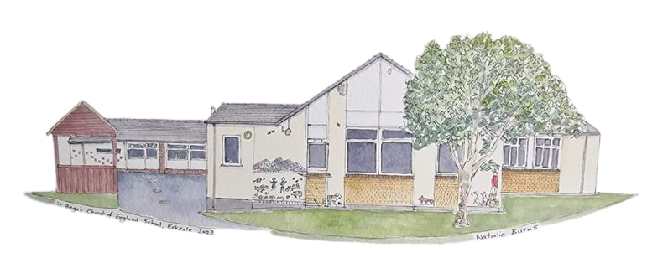

Religious Education Policy 2023-2025

Our policy has been written taking into account the Church Of England Education Office’s “Religious Education in Church of England Schools: A Statement of Entitlement (the Statement of Entitlement); the SIAMS Framework (2023); and the Cumbria Agreed Syllabus for Religious Education.

Our vision for Religious Education (RE)
At this school, RE expresses and strengthens our vision, ethos and values that are at the heart of what we aim to do in every aspect of school life that offers human flourishing for all. The importance placed on the development of the whole child spiritually, morally, socially, culturally (SMSC) and intellectually is reflected in the RE curriculum.
At St Bega’s Church of England School where pupils and staff come from different faiths and none, RE is a highly valued academic subject that enables understanding of how religion and beliefs affect our lives. There is ‘a commitment to generous hospitality, being true to our underpinning faith, but with a deep respect for the integrity of other religious traditions (and worldviews) and for the religious freedom of each person’, Statement of Entitlement 2019.
The school provides a RE curriculum that is rich and varied and studies a range of world religions and worldviews. At the heart of RE in this school is the teaching of Christianity, rooted in the person and work of Jesus Christ that enables learners to acquire a thorough knowledge and understanding of the Christian faith.
Our aim is to provide a wide range of opportunities for learners to understand and to make links between the beliefs, practices and value systems of the range of faiths studied. We aim to provide suitable learning opportunities that match the needs of all children. This includes providing relevant support, adapted activities and using a range of teaching and learning styles within lessons.
Pupils are encouraged to know about, understand and respond to the ultimate questions of life and ethical issues. Our curriculum inspires pupils to explore, develop and affirm their own faith/worldviews and values whilst having respect for the faith, beliefs and values of others. We are committed to education for wisdom, hope, community and dignity.
Encountering religion and belief includes:
- Enquiry into and investigation of the nature of religion;
- Key beliefs and teachings, practices;
- Impact on the lives of believers and communities;
- Different ways of expressing beliefs, teachings and practices;
- Developing pupil skills of interpretation, analysis and explanation in relation to religion;
- Pupils’ communication of their knowledge and understanding using specialist vocabulary;
- Pupils reflection on and response to their own experiences, questions of identity and belonging, meaning purpose and truth, values and commitment; and
- Development of religious literacy.
Aims

In keeping with the expectations set out in the Statement of Entitlement, the aims of RE in this school are:

- To enable pupils to know about and understand Christianity as a diverse global living faith through the exploration of core beliefs, using an approach that critically engages with biblical text.
- To enable pupils to gain knowledge and understanding of a range of religions and worldviews appreciating diversity, continuity and change within the religions and worldviews being studied.
- To facilitate pupils’ engagement with challenging questions of meaning and purpose raised by human existence and experience.
- To enable pupils to recognise the concept of religion and its continuing influence on Britain’s cultural heritage and in the lives of individuals and societies in different times, cultures and places.
- To encourage pupils to explore their own religious, spiritual and philosophical ways through living, believing and thinking.

Legal Framework

As a voluntary aided school, as required by law, we provide RE in accordance with our trust deed.

Parents have a legal right in accordance with the Education act 1996 to withdraw their children from RE lessons. As this subject is central to the life and identity of St Bega’s Church of England School, we ask parents to discuss with the head teacher any reasons they might have for doing this. We aim to provide a quality RE curriculum that can be sensitively and appropriately taught to all pupils, by all staff. We ask that requests for full or partial withdrawal from RE should be made in writing to the headteacher.
Curriculum for Religious Education

RE is an academic subject that has a high profile in our school curriculum. It is given priority by leaders, including governors, who ensure that the teaching, learning and resourcing of RE is comparable with other curriculum subjects.

This means that the RE curriculum:

- is intrinsic to the outworking of our distinctive Christian vision in enabling all pupils to flourish;
- contributes to British values and to pupils’ spiritual, moral, social and cultural development;
- is delivered in an objective, critical and pluralistic manner to engage and challenge all pupils through an exploration of core concepts and questions;
- provides meaningful and informed dialogue with a range of religions of worldviews;
- reflects a good balance between the disciplines of theology, human science and philosophy;
- enables pupils to acquire a rich, deep knowledge and understanding of Christian belief and practice, including the ways in which it is diverse;
- provides opportunities for pupils to understand the role of foundational texts, beliefs, rituals and practices and how they help to form identity in a range of religions and worldviews;
- ensures that all pupils’ contributions are valued in RE as they draw on their own experiences and beliefs;
- is adapted to ensure all pupils make progress and flourish.

In addition to providing RE in accordance with our trust deed we use Questful RE and Inspiring RE in our teaching of the subject.

There are clear learning outcomes for all units of work, based on the appropriately high expectations we have for all our pupils. Our RE curriculum is sequential and builds on prior learning which ensures that there is continuity and progression for all pupils as they move through the school.

Curriculum balance and time

In this school the faiths/worldviews taught in RE are:

- in KS1, Christianity and Islam, Sikhism, Judaism, Hinduism, Buddhism
- in KS2, Christianity and Islam, Sikhism, Judaism, Hinduism, Buddhism, Atheism and Agnosticism

RE has 5% of curriculum time; 50min a week in the foundation stage and key stage 1 increasing to 45 hours per year (1 hour a week) in key stage 2.

Of the RE taught, 70% focusses on Christianity and 30% focusses on other faiths.

A range of visitors support the teaching of RE, and whenever possible, there will be planned visits to places of worship and other places of interest.

Spiritual, Moral, Social and Cultural Development (SMSC) / British Values

- RE is a key opportunity to develop morally, spiritually, socially and culturally. We invite pupils to reflect on their personal responses to issues and consider respectfully those of others.
- We encourage pupils to consider the answers offered by faith and other groups to questions of meaning and purpose and to problems within societies as well as their own experiences.
- RE also strongly supports the school’s citizenship work by introducing pupils to the significance of belonging to a community, diversity within communities, faith rules and their application to moral and ethical issues and cultural influences on religious practice. This includes work on the British Values of democracy, the rule of law, individual liberty, and respect.

Health and Safety

Health and safety issues may arise in RE on a number of occasions for example, when pupils:

- Handle artefacts
- Consume food
- Visit places of places.

Teachers will conform to guidelines in the school’s health and safety policy in these circumstances.

Recording, Feedback and Assessment

Teachers will:
- identify development in the different areas of learning in the subject beyond the acquisition of factual knowledge;
- recognise the range of skills and attitudes which the subject seeks to develop;
- employ well-defined criteria against which to measure progress and achievement;
- ensure that pupils are involved in determining and understand their next steps;
- enable effective tracking of pupil progress to identify areas for development in pupil’s knowledge and understanding, as well as whole school areas for development; and
- provide accurate reports to parents/carers.
Leadership & Management
The teaching, assessment and resourcing of RE is managed by the RE subject leader (in collaboration with leaders) to ensure that statutory requirements and those set in the Statement of Entitlement are met.
The RE subject leader will:
- will support and regularly monitor the subject across the school for its strengths and areas for development in line with SIAMS and Ofsted guidance about self-evaluation;
- undertake relevant and regular CPD to keep their subject knowledge and expertise up to date, and to ensure that staff receive appropriate training for the teaching and assessment of RE;
- report regularly to the governing body so that everyone has an overview about progress and outcomes in RE; and
- ensure that RE provision reflects diocesan advice and recommendations.
Review

There will be a review of this policy every 2 years. Its impact will be monitored by the Headteacher together with the governors. This will include discussions with pupils, other members of staff, observing teaching and scrutinising pupils’ work.

Date of policy: July 2023
Review date: July 2025
Signed: E.Stellmacher

