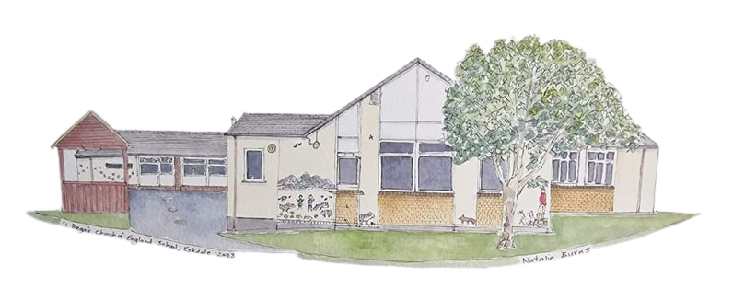
St Bega’s C of E Primary School
Spirituality Policy 2023-2025
At St Bega’s, we believe that spirituality is a vital component of a child’s holistic education. We believe that every child should have the opportunity to explore their spirituality and develop a deeper understanding of themselves and their place in the world.
Our school policy on spirituality aims to provide guidance and support on how we can cultivate a spiritually enriching environment for our pupils.
What is Spirituality?
Spirituality is a complex and multifaceted concept that can be defined in a variety of ways depending on cultural, religious, and personal perspectives. At St Bega’s, we view spirituality as an individual’s personal search for meaning, purpose, and connection to something greater than themselves. We recognise that spirituality can take many different forms and can coexist with different religious beliefs or no religious affiliation at all.
Creating a Spiritually Enriching Environment
We believe that the school environment is critical in cultivating a spiritually enriching experience for our pupils. To achieve this, we have established the following practices:
1. Mindful Practice: We encourage all members of our school community to engage in mindful practices such as meditation or reflection to help them connect with their spirituality. This is an embedded part of our nurture work and also takes place at different times throughout the day for whole classes, groups and individual children.
2. Respect for Diversity: We celebrate and respect the diversity of spiritual beliefs and religious traditions within our school community.
3. Compassionate Behaviour: We foster a school culture based on compassion, friendship, and community. We encourage our pupils to develop empathy and compassion towards their peers and staff.
4. Promoting Curiosity: We encourage our pupils to explore their spirituality through questioning, dialogues, and self-reflection.
5. Creating a Safe Space: We provide a safe space where pupils can express their spiritual beliefs and concerns without fear of discrimination or ridicule. This includes counselling services for those who may be experiencing spiritual or existential difficulties.

Curriculum and Extra Curricular Activities
Our curriculum encourages pupils to develop their spiritual understanding and awareness. Our school organises the following activities:
1. PSHE: We dedicate time each week for Mindful PSHE, where pupils share thoughts, feelings, and ideas on a particular topic. PSHE time provides a safe space for pupils to express themselves, connect with their classmates, and explore their spirituality.
2. Religion and Worldviews: We provide a Religion and Worldviews curriculum that exposes children to different religious traditions and practices. We believe that familiarity with different religious traditions fosters understanding and respect for diversity, and enriches pupils’ spiritual development.
3. Celebration of Festivals: We recognise important festivals such as Christmas, Diwali, Eid al-Adha, Hanukkah, and Vesak. These festivities provide opportunities for pupils to learn about different cultures, religions, and spirituality.
4. Extra-Curricular Activities: We organise various extra-curricular activities such as sports, nature walks, and exploring nature, that help pupils connect with their spirituality in different ways.
Parent and Community Engagement
We encourage parents and the wider community to participate in the spiritual development of our pupils. The following practices are in place:
1. Parental Involvement: We create a partnership with parents to maintain open communication regarding their child’s spiritual development. We also encourage parents to share their beliefs and traditions with our school community.
2. Community Outreach: Our school seeks opportunities where our children can contribute positively to the wider community through meaningful and spiritually enhancing activities such as charity work and promoting the work of our residential homes within our locality.

The development of spirituality in our children is an essential aspect of St Bega’s C of E Primary School’s education. We hope that this policy provides guidance on how we intend to create a spiritually enriching environment within our school community.
We recognise that the spirituality of the individual is far too complex to fit into one school policy, but we believe that the guidance we provide will help our children develop a deeper sense of spiritual understanding and appreciative of their place in the world.

